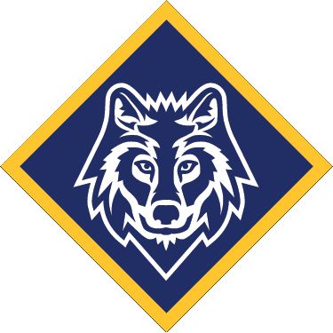
You’re coming to….

Gold Camp XIII!

Rowallan Scout Camp
Riddells Creek
7pm Sharp, Fri 25th - 3pm, Sun 27th March, 2022

Welcome to Gold Camp XIII! It’s a fantastic camp only for older Cubs – you’ll learn more about how to go out and earn your Grey Wolf Award, get a chance to earn parts of the core OAS badges and experience a bit of what it’ll be like to be in Scouts! You’ll be camping with Cubs and Leaders from Rosanna, and other Cub Packs from across Melbourne and Victoria.

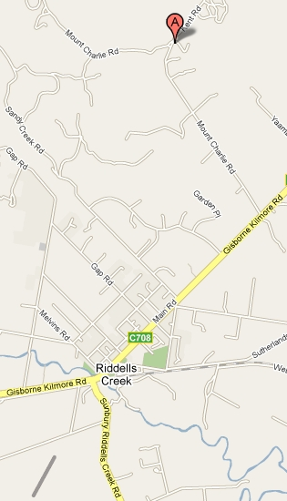
Location: Rowallan Scout Camp, Kent Rd, Riddells Creek, Vic –
https://goo.gl/maps/BYesyeFXxBH2

About it: We’ll be staying in dormitories this year, eating our meals (some of which you CUBS will cook!) and will be having tons of fun while we learn some great stuff. We’ll be using the Pack Holiday Centre, with full toilet / shower facilities and full shelter if the weather gets too rough.
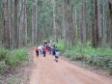
Doing? The Grey Wolf is the highest award in Cubs and has to be done by the Cubs themselves… this Camp aims to help you learn what to do and experiment for yourself – even going on a 2 hour practice hike! – so you can go home and be more confident in earning your Grey Wolf. ALSO you’ll get the chance to earn parts of the OAS Badges you’ll need for the Grey Wolf AND you’ll try some Scout stuff – like cooking in Patrols, and more! Don’t miss it!
Leaders: Leaders/Parent Helpers from all
Packs attending.
Take: Your Kit list is attached. Please print out and bring your Operoo record OR fill out and bring the attached Health form.
Contact: Your contact at the camp will be your attending Cub Leader/Parent Helper

